

crown bank of canada

assignment 7 -database design

03-14-2024

**TEAM #6**

ELSIE UMUKORO [PROJECT SPONSOR]

RAMYA KRISHNASAMY [PROJECT MANAGER]

SHUBHAM KIRITKUMAR THANKI [DATA ANALYST]

KUNJ SHAH [BUSINESS ANALYST]

SHOURYA SAHNI [QUALITY ANALYST]

SHRAVANI SOUJANYA KODAM [DOCUMENTATION EXPERT]

NEHA LINGAMPALLY [FINANCIAL REPRESENTATIVE]

Table of Contents

**No table of contents entries found.**

1.0Database Design

1.1Data Elements and Definitions

Customer Table

|  |  |  |
| --- | --- | --- |
| **Elements** | **Data Type** | **Definition** |
| CUSTOMER_ID (PK) | INT | Unique identifier for customer |
| FIRST_NAME | VARCHAR | First Name of the Customer |
| LAST_NAME | VARCHAR | Last Name of the Customer |
| SIN_NUMBER | INT | Sin number of the customer |
| EMAIL | VARCHAR | Email address of the customer |
| PHONE | VARCHAR | Phone number of the customer |
| ADDRESS | VARCHAR | Address of the Customer |
| CITY | VARCHAR | City of Residence of the Customer |
| POSTAL_CODE | VARCHAR | Postal Code of the Customer |
| COUNTRY | VARCHAR | Country of residence of the customer |

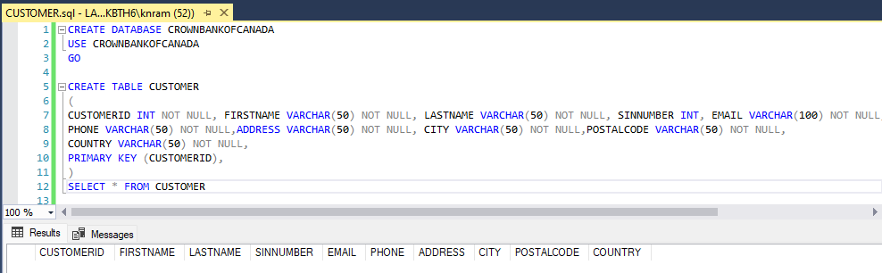

Accounts Table

|  |  |  |
| --- | --- | --- |
| **Elements** | **Data Type** | **Definition** |
| ACCOUNT_ID (PK) | INT | Unique identifier for accounts |
| CUSTOMER_ID (FK) | INT | Reference the Customer's table |
| LOAN_ID (FK) | INT | Reference the Loan table |
| BRANCH_ID (FK) | INT | Reference the Branch table |
| ACCOUNT_NUMBER | VARCHAR | Unique account number |
| ACCOUNT_TYPE | VARCHAR | Type of Account |
| BALANCE | DECIMAL | The current balance in the account |
| OPEN_DATE | DATE | When the account is opened |
| STATUS | VARCHAR | Status of the account |

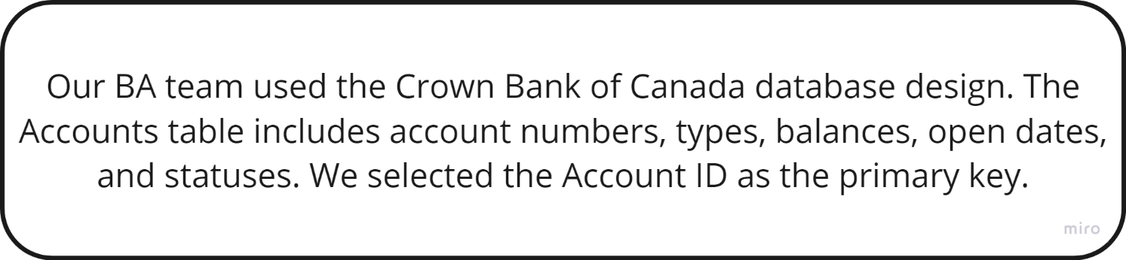

Loans Table

|  |  |  |
| --- | --- | --- |
| **Elements** | **Data Type** | **Definition** |
| LOAN_ID | INT | Unique identifier for loans. |
| LOAN_AMOUNT | DECIMAL | Amount of the loan. |
| INTEREST_RATE | DECIMAL | The interest rate associated. |
| LOAN_TERM | INT | Term of the loan in months. |
| START_DATE | DATE | Date when the loan was initiated. |
| STATUS | VARCHAR | Status of the loan. (Closed or Active) |

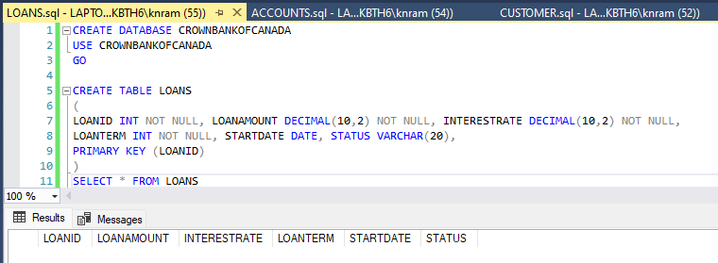

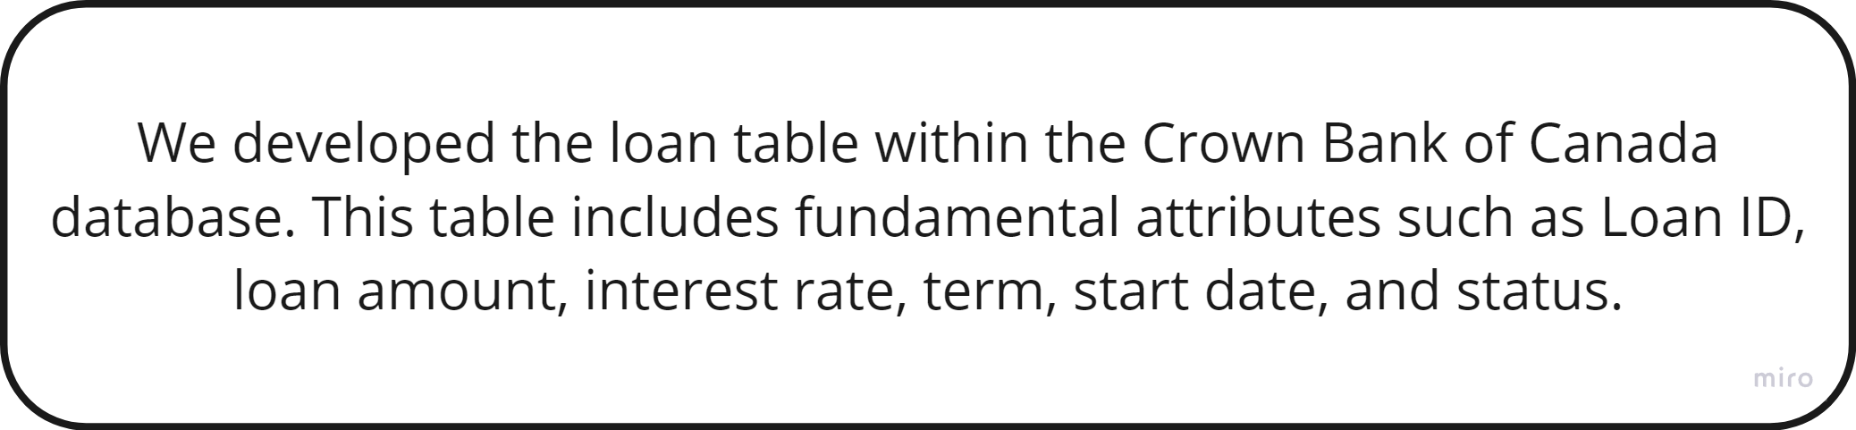

Payment Table

|  |  |  |
| --- | --- | --- |
| **Elements** | **Data Type** | **Definition** |
| PAYMENT_ID (PK) | INT | Unique identifier for payments. |
| LOAN_ID (FK) | INT | Reference the loan table. |
| PAYMENT_DATE | DATE | Date of the payment. |
| AMOUNT | DECIMAL | Amount of the money paid. |
| STATUS | VARCHAR | Status of the payment. |
| PAYMENT_METHOD | VARCHAR | The mode used for executing the payment. |

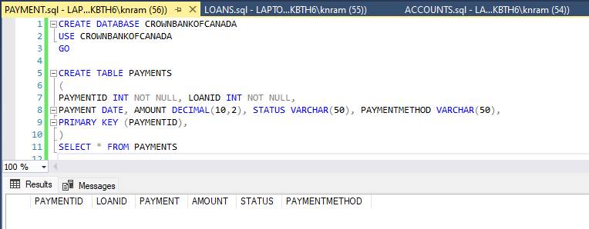

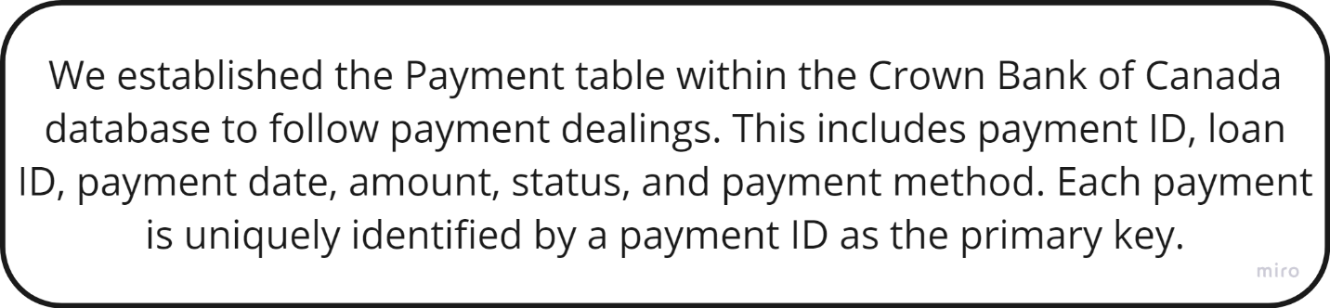

Branch Table

|  |  |  |
| --- | --- | --- |
| **Elements** | **Data Type** | **Description** |
| BRANCH_ID | INT | Unique identifier for Branch |
| BRANCH_NAME | VARCHAR | Name of the bank branch |
| BRANCH_ADDRESS | VARCHAR | Address of the branch |
| TRANSIT_ID | INT | The transit ID is assigned to the bank branch for transactional purposes. |

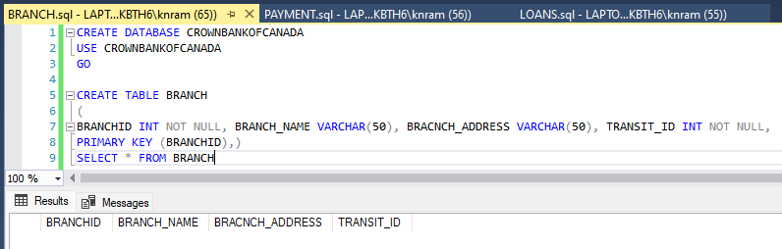

1.2 Relational Database outline using VISIO.

We have developed several vital relationships between tables to allow efficient data management and retrieval as part of our **database** development for the **Crown Bank of Canada.**

First, the **Customer ID** field is a foreign key in the **Loan table** that references the customer ID field. This means that we can link each loan with its customer in order to keep track of and manage loans accurately.

Likewise, a **customer ID** area in the **Accounts table** is used as an external key that links all account entries to their corresponding customer record in the Customer list. This relationship enables account management methods to be simplified and enables the alignment of customer accounts with each other.

In addition, a **foreign key** is fitted by the **Branch ID** field in the **Accounts table** and refers to the branch Foreign Key fields. This link enables the management and reporting of branch accounts, permitting us to identify each account associated branches.

The **loan ID** area is used as an FK in the **Payment table** and that is referenced. This relationship helps to link each payment dealing to its related loan form based on the loan ID to ensure proper payment search and reconciliation.

To ensure the consistency and reliability of data in the Crown Bank of Canada database, these external key relationships recreate important role in supporting data integrity and enforcing interoperability restrictions between related tables.